Step 3 – Load test the servers

Java:

1. threadGroupSize = 10, numThreadGroups = 10, delay = 2
2. 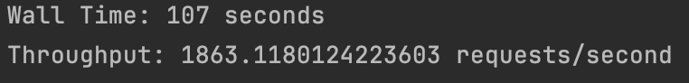threadGroupSize = 10, numThreadGroups = 20, delay = 2
3. A number on a black background

   Description automatically generatedthreadGroupSize = 10, numThreadGroups = 30, delay = 2

Go:

1. threadGroupSize = 10, numThreadGroups = 10, delay = 2
2. A close up of numbers

   Description automatically generatedthreadGroupSize = 10, numThreadGroups = 20, delay = 2

1. threadGroupSize = 10, numThreadGroups = 30, delay = 2

### Step 5: Load test the servers again

Java:

1. **threadGroupSize = 10, numThreadGroups = 10, delay = 2**

1. **threadGroupSize = 10, numThreadGroups = 20, delay = 2**

1. **threadGroupSize = 10, numThreadGroups = 30, delay = 2**

Go:

1. **threadGroupSize = 10, numThreadGroups = 10, delay = 2**

1. **threadGroupSize = 10, numThreadGroups = 20, delay = 2**

1. **threadGroupSize = 10, numThreadGroups = 30, delay = 2**

### Step 6: Plot Performance

### 

### Java Server:

### Go Server:

